St. Michael’s School Newsletter
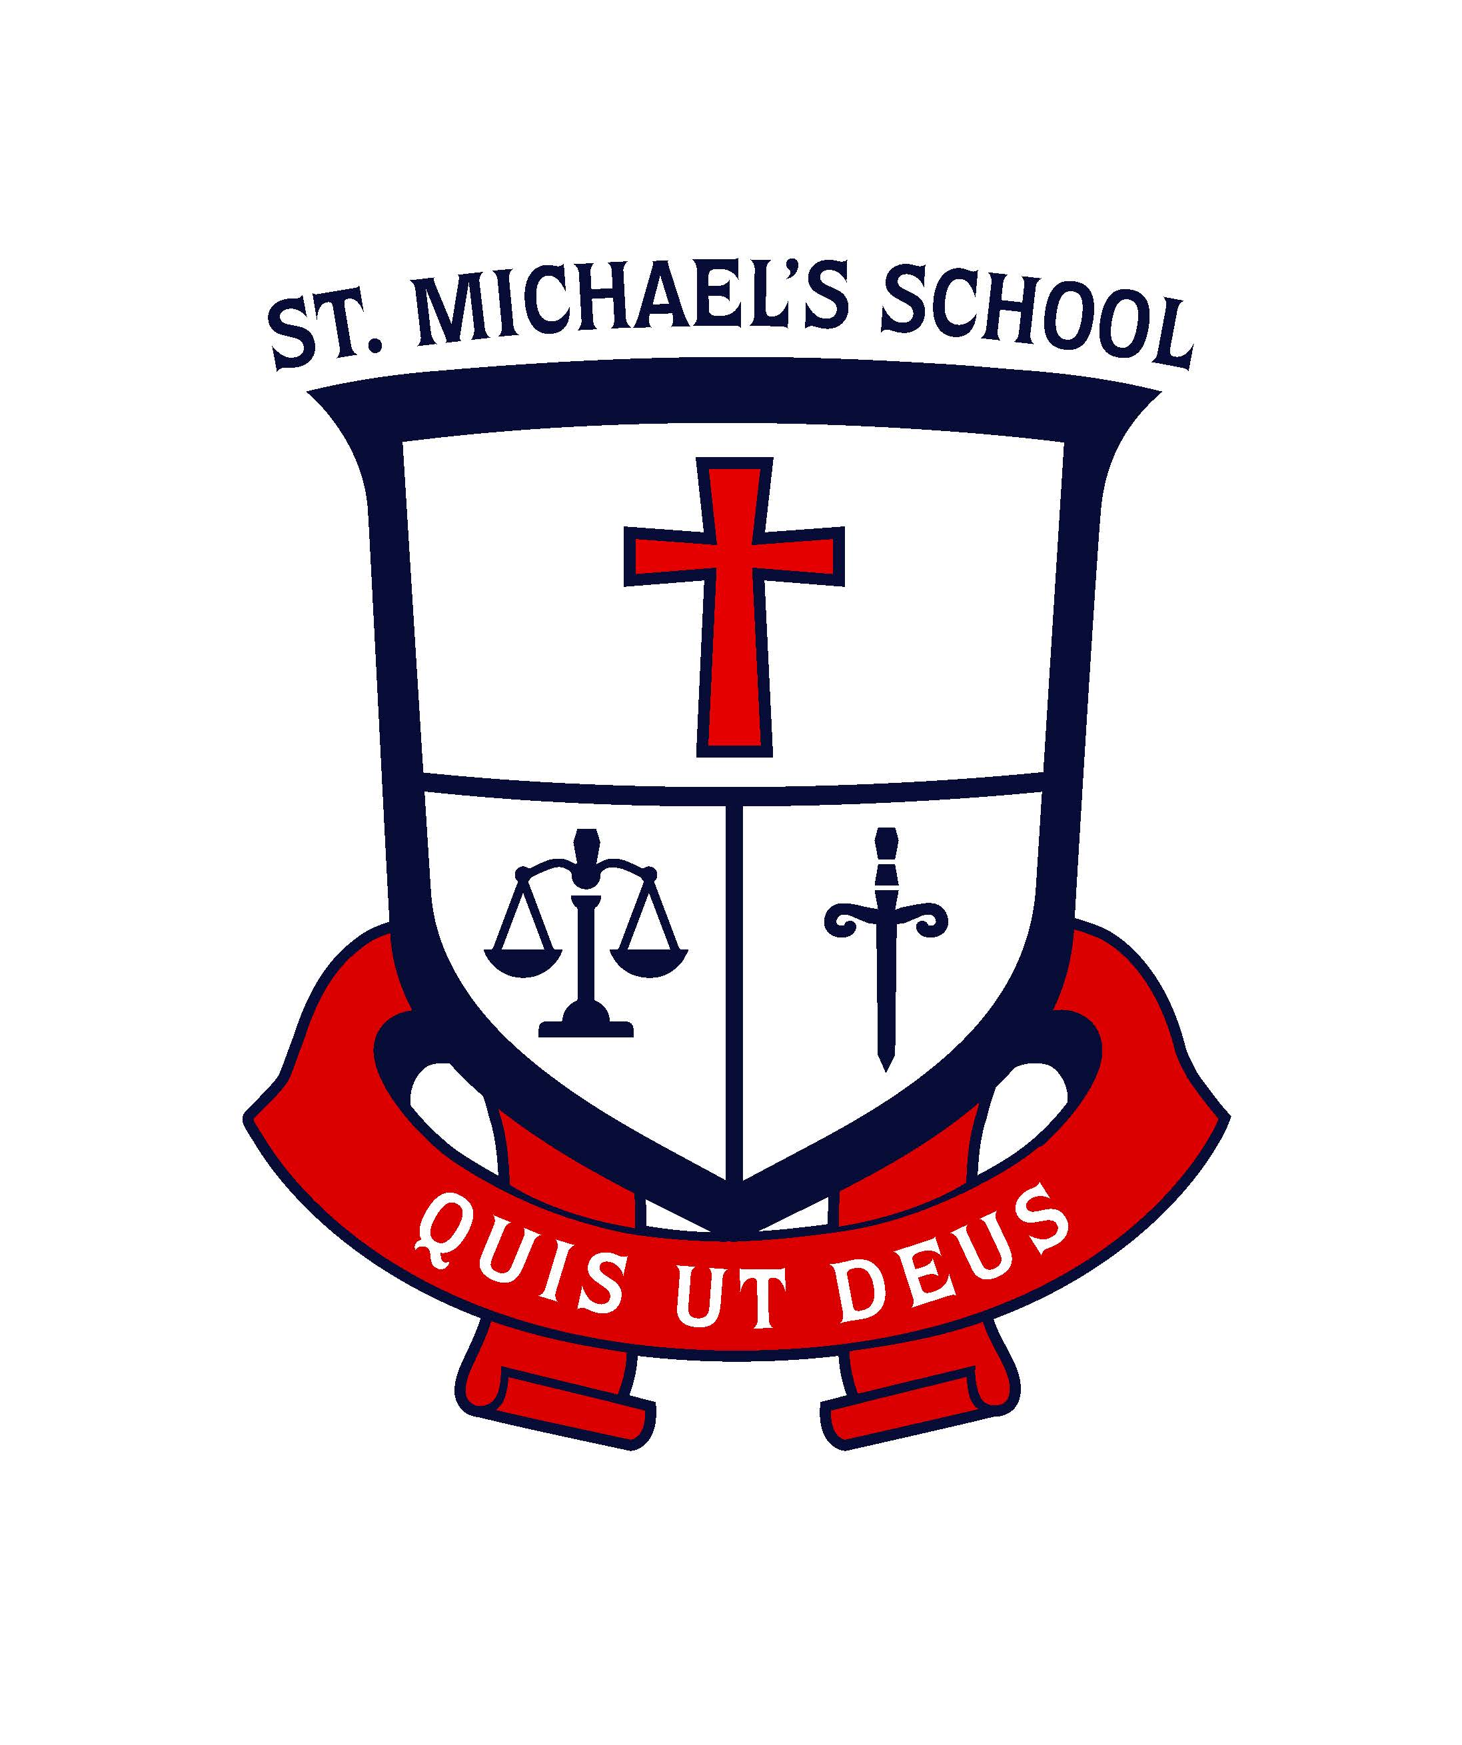

9387 Holmes Street, Burnaby, BC V3N 4C3

Telephone (604) 526-9768 Fax (604) 540-9799
Website: www.stmichaelschool.ca

October 8, 2020 Number 5

Our Virtue Focus for the Month of October - Respect
During this month of October, we celebrate the virtue of respect. We all deserve to be treated respectfully by others. However, in order to be respected, we also have to respect ourselves. Everyone has a right to go to school/work free of gossip, name-calling, and put-downs. We should expect to be treated with respect by everyone we meet – our brothers and sisters in Jesus.
“Respect yourself and others will respect you.” Confucius

A respectful person…
† uses a positive tone of voice and body language
† avoids swearing, name-calling, put-downs, and inappropriate gestures
† says ‘Excuse me’, ‘Please’, ‘Pardon me’
† avoids gossip

OUR DAILY PRAYER FOR OCTOBER
Let us pray for the virtue of respect so that everyone we meet will feel like
we are their brother or sister in Christ. Amen

THANKSGIVING HOLIDAY
This is a reminder that Monday, October 12th is Thanksgiving Day and, therefore, the school will be closed.

RESERVED PARKING SPOT!
The reserved parking spot in the main parking lot (the spot nearest to the playground) was purchased by the Li family (Rickey in Gr. 5 and Henry in Gr. 2) during the last Auction in 2019. Due to the pandemic disruptions the Li family still has ownership of the parking spot. PLEASE DO NOT PARK IN THIS SPOT. During the next auction the parking spot will be available for purchase.

P.E. DANCE UNIT FOR GR. 4-7 STUDENTS
Mr. Roder has arranged for instructors from DANCEPL3Y to provide dance instruction to our students in Gr. 4-7 the week of October 19th. Students will explore simple movements from a variety of dance styles from around the world. The DANCEPL3Y company will follow all health and safety guidelines. You can also find DANCEPL3Y COVID Policies and Procedures at:
- COVIDPolicy_PL3YED_Aug2020.pdf
- PLAYING SAFE with COVID-19 - POSTER.pdf
In order maximize instruction, the students will be participating in their learning cohorts.

THE GREAT BRITISH COLUMBIA SHAKEOUT!
On Thursday, October 15th, our students will be participating in the province-wide “Drop, Cover, and Hold On” drill. All residents across BC are encouraged to take part in this largest earthquake drill in Canadian history called “The Great British Columbia ShakeOut”!
We encourage our families to practice an earthquake drill at home. More information can be found at https://www.shakeoutbc.ca

NON-UNIFORM DAY
The Student Leadership Team will be hosting a non-uniform day on Thursday, October 29th. The theme for this non-uniform day is “Christian Career Day”. Students who choose to wear items connected with the theme will need to bring in a minimum donation of a toonie for our social outreach projects. Students who do not wish to participate must wear their school uniform. Think about careers that are a “life of service”; priests, nuns, teachers, emergency services, saints, etc…

MANDATORY - GRADE 7 CONFIRMATION MEETING
There will be a Confirmation meeting on Wednesday, October 21st at 7:00 pm in the gym for those parents whose children will be receiving the sacrament of Confirmation this school year.
Safety measures:
- Only one parent is to attend
- Everyone in attendance must wear a mask
- Seating will ensure physical distancing

The Grade 7 Enrolment Mass will take place during the Grade 7 Friday school Mass which will be on Friday, October 30th.

MORNING DROP OFF AND AFTERSCHOOL PICK UP PROTOCOLS
Thank you for adapting so well to the new protocols. In order for this system to work, we encourage parents to drop off between 8:30 and 8:40 as opposed to all entering the parking lot at 8:40-8:45. We have a teacher supervisor and an EA outside at 8:30 am to supervise the children. Parents do not need to stand and wait for their children to go into the school. Once dropped off, children are required to go directly to their line up area.
Thank you, as well, for your patience when exiting the parking lot as we know it can get busy.

COAT DRIVE!
Hello parents! It is time to collect for our annual coat drive. This year will look a bit different and because of extra Covid-19 precautions we must ensure that the coats are collected safely. If you have any coats you would like to donate please wash them (very important due to Covid-19). Once the coats are dry, zip them up, and clearly label the coats with painter’s tape (or similar) with the size. Place the coats in a plastic bag and label the bag with the different coat sizes included in the bag. If possible, put similar sizes in the same bag i.e. sizes 6 & 7 together and then sizes 10 & 12 together.
Washing and clearly labelling the donated items will really help in speeding up the process of getting the coats to the children because it will aid in the sorting.

The Coat Drive collection bin will be placed behind the school using the back door of the music room. To ensure everyone’s safety the following changes will be made with respect to collection:
1. Parents assisting with collection will be wearing masks and gloves. Hand sanitizer will also be available.
2. The bin cannot be left outside for a few weeks as it has in previous years therefore the collection bin will be available:

Thursday Oct 8 and Friday Oct 9 from 2:45-3:00
Thursday Oct 15 and Friday Oct 16 from 2:45-3:00

If you have any questions or concerns please contact Betty at bmulingtapang@me.com

INDIVIDUAL PHOTO RE-TAKES
Lifetouch photos were sent home this week. Re-take Day is October 21st for those students who were away on the first photo day or for those who are not satisfied with their original portraits.

You must return the original proofs to the photographer on this day. If you don’t return the proofs, you will not have a re-take done.

Also, please advise your child if you want him/her to get re-takes. It is not the responsibility of school staff to go through your child’s backpack to see if you are returning the proofs for re-takes.

Thought of the week…
“God never sends you into a situation alone. God goes before you. He stands beside you. He walks behind you. Whatever situation you have right now, be confident. God is with you.”

