Sun | Mon | Tue | Wed  Waste Free Wednesdays | Thu | Fri | Sat
29  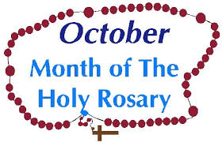 | 30 | 1  Confessions  Grade 4  FSA Assessment  (October 1st to November 8th)  Side Dish  Chicken Souvlaki | 2 | 3  Assembly – Grade 7  9:15am  Hot Lunch  Grilled Cheese, Sushi  Fresh Fruit Cup | 4  School Mass  Used-uniform store  3:00pm to 3:30pm | 5  World Teachers’ Day
6  8:30am School Choir  Pancake Breakfast | 7  Fire Drill | 8  Confessions  Grade 3 | 9  Grade 6 & 7  Outdoor Education | 10  Grade 6 & 7  Outdoor Education  Hot Lunch  Pasta  Booster Juice | 11  School Mass  Grade 6 & 7  Outdoor Education | 12
13  October 17-23 National School Safely Week | 14  NO SCHOOL  THANKSGIVING  HOLIDAY  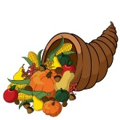 | 15  Confessions  Grade 7  Side Dish  Spring Roll | 16  Apple Sale Day  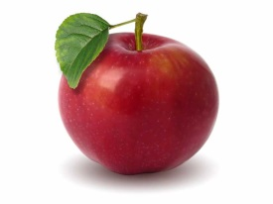 | 17  Early Warning System Test 11:00  “Great Canadian Shake Out”  (School Wide Drill)  Hot Lunch  Hamburger, Hot Dog,  Caesar Salad, Jello | 18  Professional Development Day  NO SCHOOL | 19
20  St. Michael’s Annual Walkathon! | 21 | 22  Confessions  Grade 6 | 23  Lifetouch Photo  re-takes | 24  Hot Lunch  Subway,  Cookie | 25  School Mass | 26
27 | 28  Sexuality and Your Child – Grade 4, 5, 6 & 7 Parent Meeting (7:00pm) | 29  Confessions  Grade 5  Side Dish  Loaded Baked Potato | 30 | 31  Non-Uniform Day  “Christian Hero Day”  Respect  Hot Lunch  Perogies, Burrito,  Sushi, Chocolate Pudding | 1  All Saints’ Day - Mass  Interim Reports are sent out.  Used-uniform store  3:00pm to 3:30pm | 2  All Souls’ Day
October

